

**NAME:**

**SAKEENA MANZOOR**

**ROLL NUMBER:**

**FA24-BSE-129**

**COURSE:**

**OBJECT ORIENTED PROGRAM**

**SUBBMITTED TO:**

**SIR NOUMAN KAHN**

**DATE:**

**5-OCT-2025**

**COMSATS UNIVERSITY ISLAMABAD ABBOTTABAD CAMPUS**

Exercise 1:

Task 1:

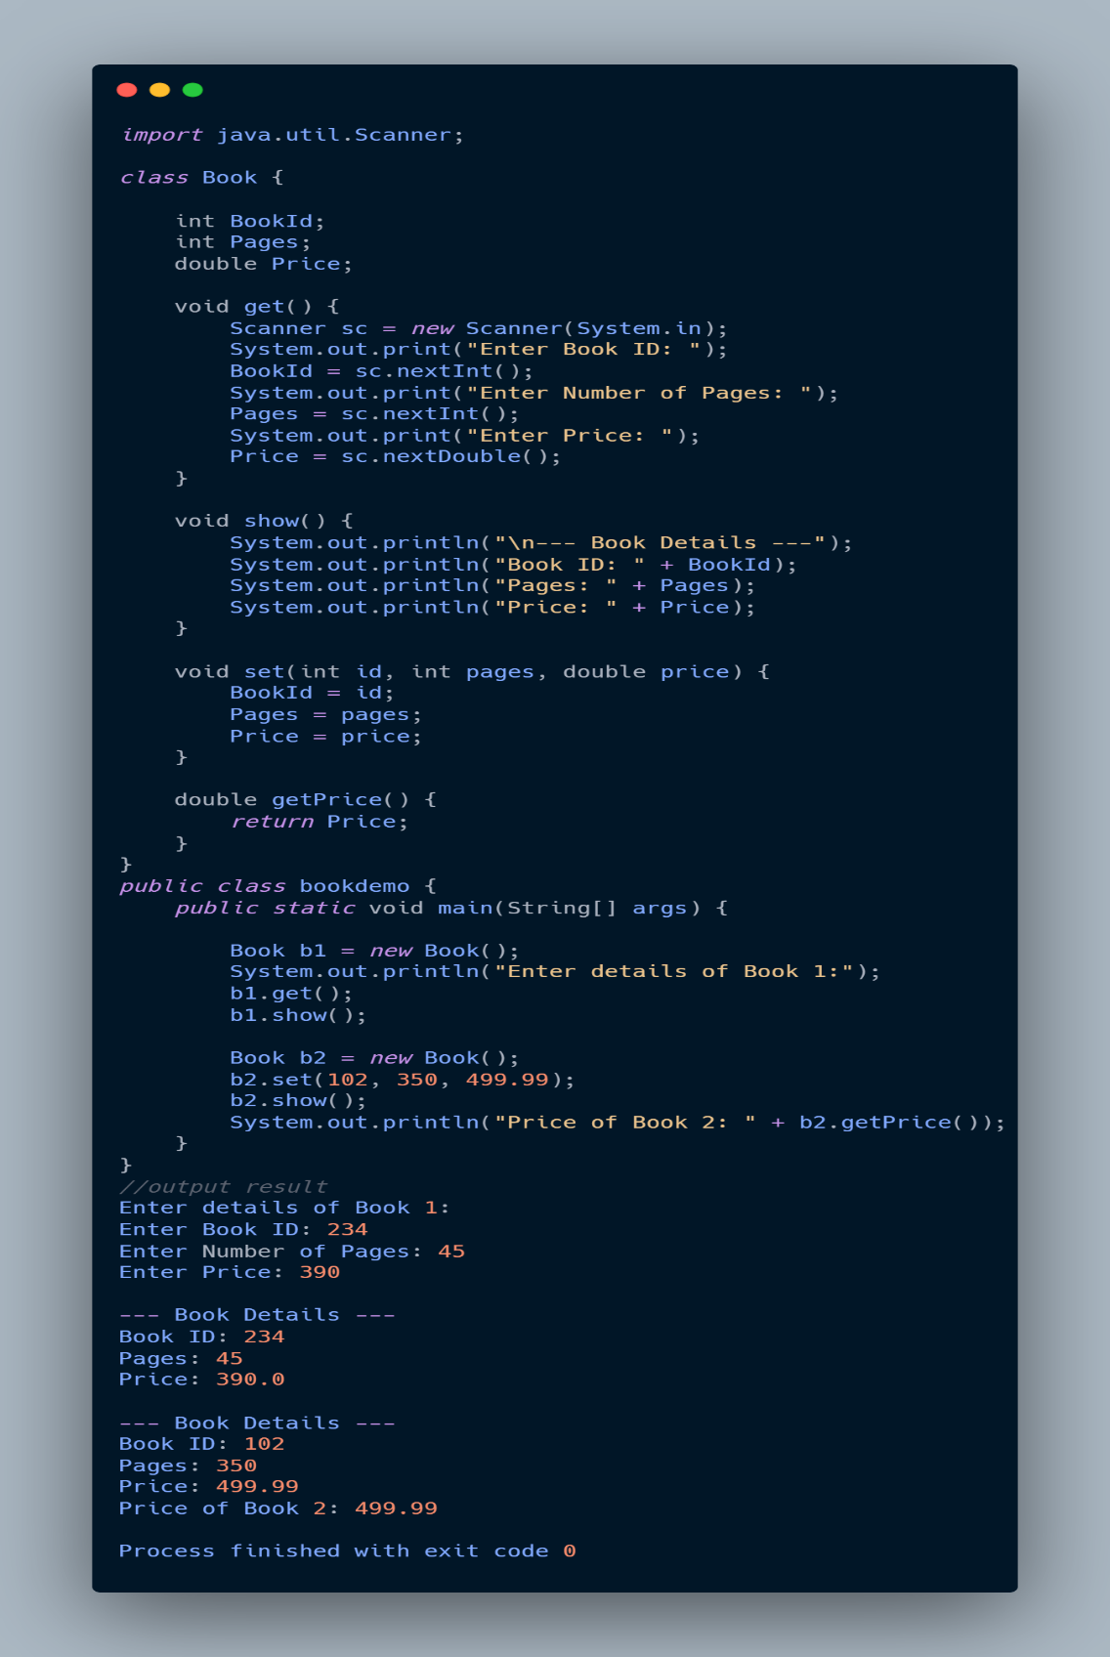

Exercise 2:

Task 2:

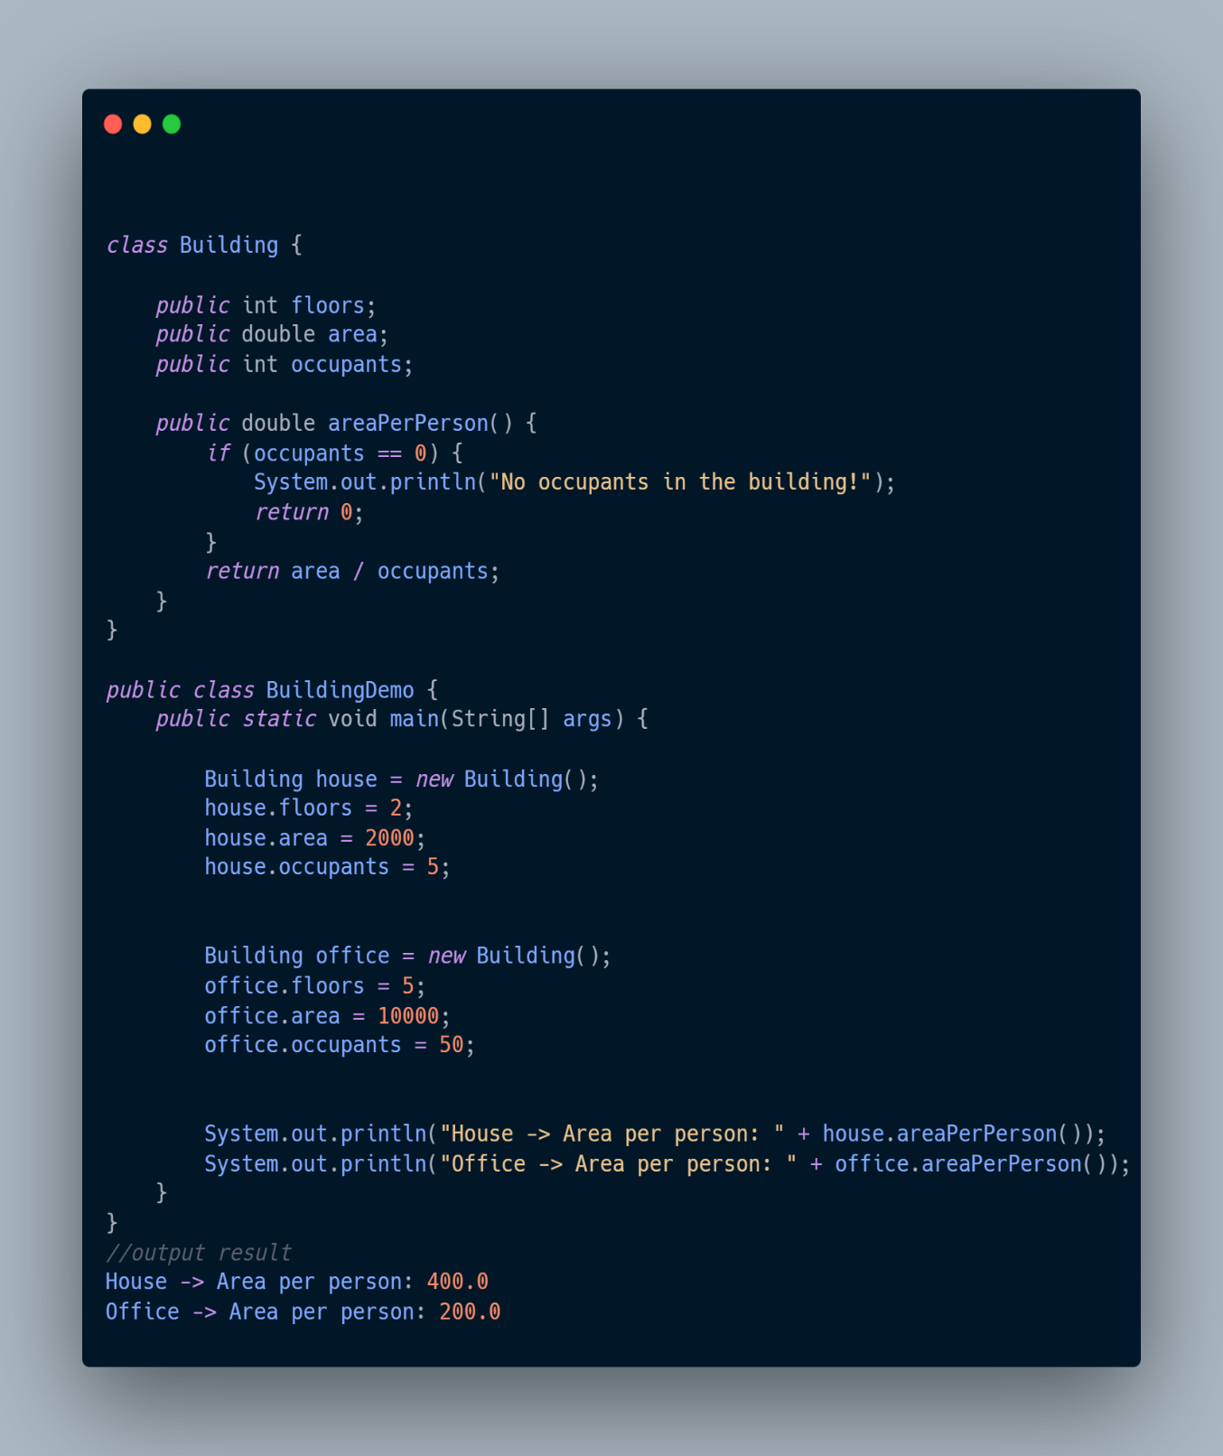

Exercise 3:

Task 3:

Part 1:

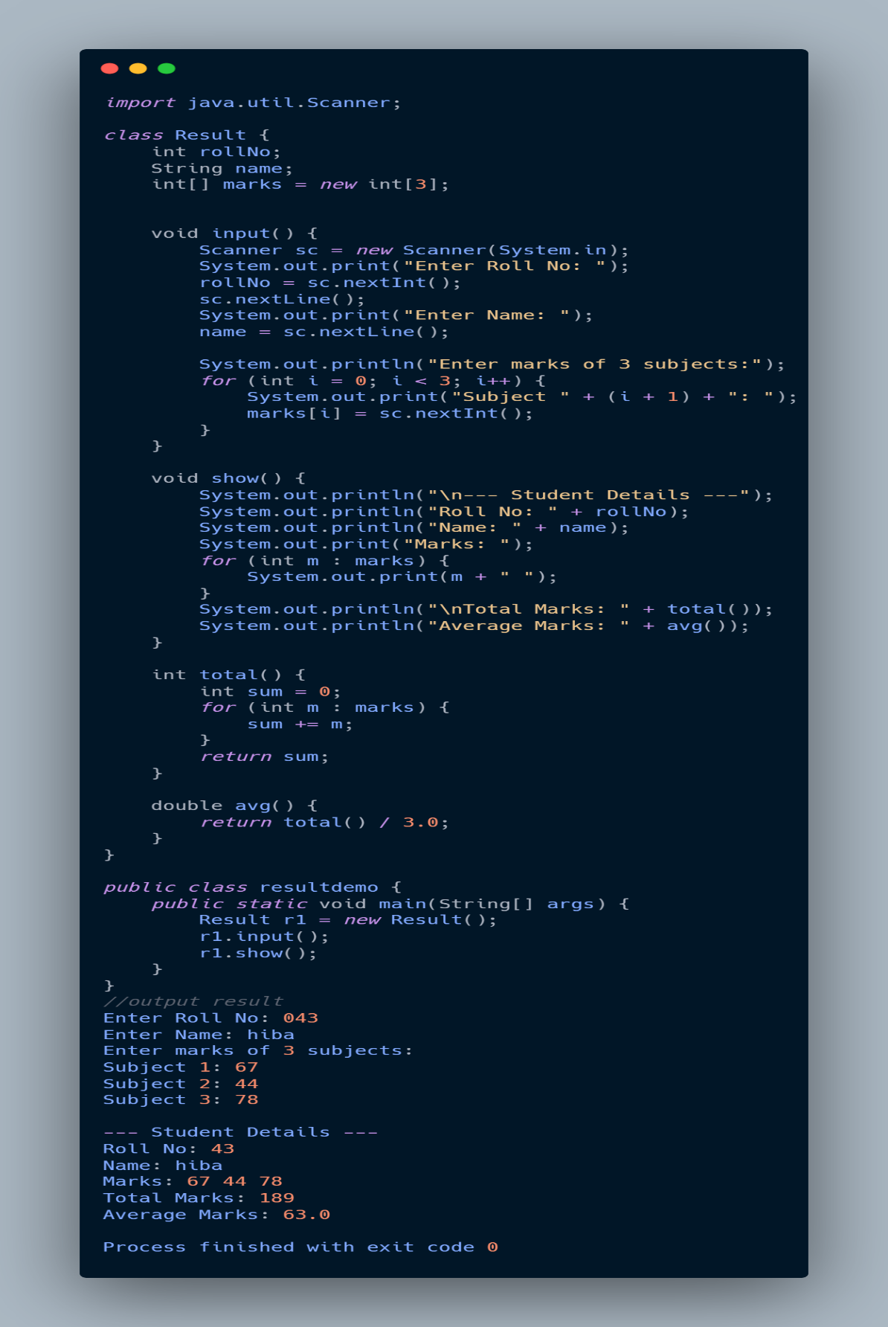

Part 2:



